**Question1:**

**Code:**

/*

Name: !you

Regstration No: SP21-BCS-OO2

Question 1: Shape

*/

import java.util.Scanner;

public class LabQ1{

public static void main(String[] args) {

int num = 0;

int i;

int j;

int k;

for(i = 8; i > 0; i--){

num = 1;

for(j = 1; j < 9; j++){

if(j < i){

System.out.print(" ");

}

else{

System.out.printf("%4d" , num);

num = num + num;

}

}

num = num / 2;

for(k = 0; k < 8 - i; k++){

num = num / 2;

System.out.printf("%4d" , num);

}

System.out.println(" ");

}

}

}

**Output:**

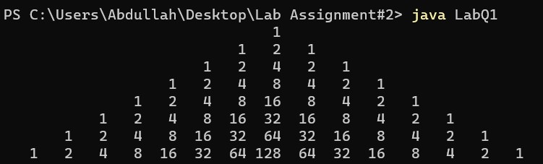

**Question2:**

**Code:**

/*

Name: !you

Regstration No: SP21-BCS-OO2

Question 2: Day of the year

*/

import java.util.Scanner;

public class LabQ2{

public static void main(String[] args) {

Scanner input = new Scanner(System.in);

String today = "";

String january = "January";

String february = "February";

String march = "March";

String april = "April";

String may = "May";

String june = "June";

String july = "July";

String august = "August";

String september = "September";

String october = "October";

String november = "November";

String december = "December";

System.out.println("Enter year");

int year = input.nextInt();

System.out.println("Enter first day of the year");

int day = input.nextInt();

for(int i = 1; i < 13; i++){

// Assigning days

if(day % 7 == 0){

today = "Sunday";

}

else if(day % 7 == 1){

today = "Monday";

}

else if(day % 7 == 2){

today = "Tuesday";

}

else if(day % 7 == 3){

today = "Wednesday";

}

else if(day % 7 == 4){

today = "Thursday";

}

else if(day % 7 == 5){

today = "Friday";

}

else if(day % 7 == 6){

today = "Saturday";

}

// calculation and final display

if(i == 1){

System.out.println(january + " 1 " + year + " is " + today);

day += 31;

}

else if(i == 2){

if(year % 4 == 0){

System.out.println(february + " 1 " + year + " is " + today);

day += 29;

}

else{

System.out.println(february + " 1 " + year + " is " + today);

day += 28;

}

}

else if(i == 3){

System.out.println(march + " 1, " + year + " is " + today);

day += 31;

}

else if(i == 4){

System.out.println(april + " 1, " + year + " is " + today);

day += 30;

}

else if(i == 5){

System.out.println(may + " 1, " + year + " is " + today);

day += 31;

}

else if(i == 6){

System.out.println(june + " 1, " + year + " is " + today);

day += 30;

}

else if(i == 7){

System.out.println(july + " 1, " + year + " is " + today);

day += 31;

}

else if(i == 8){

System.out.println(august + " 1, " + year + " is " + today);

day += 31;

}

else if(i == 9){

System.out.println(september + " 1, " + year + " is " + today);

day += 30;

}

else if(i == 10){

System.out.println(october + " 1, " + year + " is " + today);

day += 31;

}

else if(i == 11){

System.out.println(november + " 1, " + year + " is " + today);

day += 30;

}

else if(i == 12){

System.out.println(december + " 1, " + year + " is " + today);

day += 31;

}

}

}

}

**Output:**

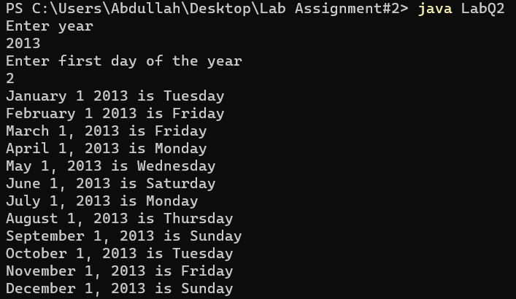

**Question3:**

**Code:**

/*

Name: !you

Regstration No: SP21-BCS-OO2

Question 1: Timing

*/

import java.util.Scanner;

public class LabQ3{

public static void main(String[] args){

Scanner input = new Scanner(System.in);

String abc = "";

String abc2 = "";

String abc3 = "";

System.out.println("Enter a sentence");

String str3 = input.nextLine();

int space = str3.indexOf(" ");

abc = capitalize(str3.substring(0, str3.indexOf(" "))) + " ";

abc3 = capitalize(str3.substring(str3.lastIndexOf(" ") + 1, str3.length()));

for(int i = 0; i< str3.length(); i++){

if(str3.substring(i, i + 1).equals(" ") && i > space){

abc2 = abc2 + capitalize(str3.substring(space + 1, i)) + " ";

space = i;

}

}

System.out.println(abc + abc2 + abc3);

System.out.println("Enter a string");

String str = input.next();

System.out.println(capitalize(str));

}

public static String capitalize(String s){

String str1 = s.substring(0, 1);

String str2 = s.substring(1, s.length());

String s2 = str1.toUpperCase() + str2;

return s2;

}

}

**Output:**

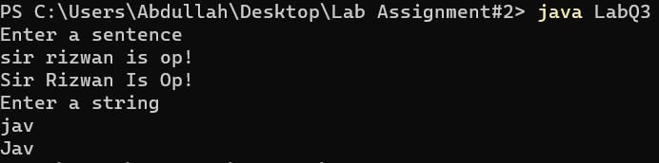

**Question4:**

**Code:**

/*

Name: !you

Regstration No: SP21-BCS-OO2

Question 1: Matrix

*/

import java.util.*;

public class LabQ4{

public static void main(String[] args){

Scanner input = new Scanner(System.in);

System.out.println("Enter the size of matrix");

int size = input.nextInt();

printMatrix(size);

}

public static void printMatrix(int length){

for(int i = 0; i < length; i++){

System.out.println("");

for(int j = 0; j < length; j++){

double random = Math.random() * 2;

if(j % 2 == 0){

System.out.print((int)random + " ");

}

else if(j % 2 == 1){

System.out.print((int)random + " ");

}

}

}

}

}

**Output:**

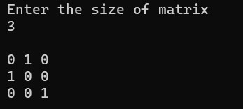

**Question5**

**Code:**

/*

Name: !you

Regstration No: SP21-BCS-OO2

Question 5: Area of a pentagon

*/

import java.util.*;

import java.lang.Math;

public class LabQ5{

public static void main(String[] args){

Scanner input = new Scanner(System.in);

System.out.println("Enter the side: ");

double side = input.nextDouble();

System.out.println("The area of the pentagon is " + area(side));

}

public static double area(double side){

double area = (5 * Math.pow(side, 2)) / (4 * Math.tan(Math.PI / 5));

return area;

}

}

**Output:**

